Curriculum Vitae

## Personal Details:

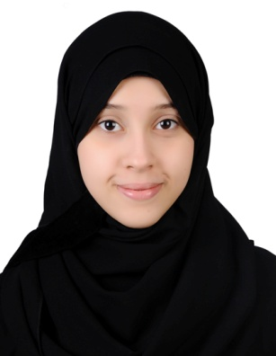

* **Name:** Roqaya Mohammed Salem Mohammed.
* **Marital status:** Married**.**
* **Nationality:** Bahraini**.**
* **Date of birth:** 21-07-1992
* **CPR number:** 920706991
* **Address:** Villa 1692 Road 7525 Block 575 Al-Janabiah
* **E-mail:** [roqia.ms@hotmail.com](mailto:roqia.ms@hotmail.com) **.**
* **Contact :** 34057886
* **Alternative NO:** 17640657 – 33777513

## Personal Statement:

## Seeking for an interview to obtain an entry-level position in the company’s. Or any other field that will enhance my career and suites my qualifications and skills.

**Educational Qualification:**

* Sept2010- Oct 2014 : University of Bahrain – College of Business Administration. **Bachelor’s degree of Science in Accounting /BSC.ACC.**
* Sep 2007 – June 2010: Secondary certificate _ Alnoor secondary Girls School.

**Work Experience:**

* July , 2014 to Aug 2014 **Electricity and Water Authority**, In Treasury & Payment & Project and Cost department as trainee.

**Main Duties &Responsibilities**

1. Internlization invoice from the account payable .
2. Issue cheque and print it.
3. classification the folders.
4. send the fax.

## Volunteer Work:

* July , 2008 to Sept, 2008 worked in **Mail Isa Town Office** .

**Certificate:**

* April – May 2014 University of Bahrain INJAZ-Business Ethics Program
* Jan 2015 Sanad Certificate of Super Speaker

(English for communication) .

**Competencies:**

* Knowledge of basic rule of Accounting .
* Familiar with Microsoft Office packages such as MS Word, Excel , Access and Power Point.
* Knowledge of basic administrative practices and procedures, including the operation of common office equipment such as typewriters, calculators, copy machines and personal computers.
* Always ready to learn every thing.
* Good and speed in typing both (Arabic & English).

**Languages:**

* Arabic : ( Mother Tongue).
* English : ( Speaking, Writing, reading & understanding).
* Little German and French.

**Hobbies:**

* Cooking , Viewing magazines and Swimming .

**References:**

* **Dr. Kousay Said:** Assistant Professor in Accounting Department .

Tel :17437761 – (+973) 39976010

E-mail: [Ksaid@Uob.edu.bh](mailto:Ksaid@Uob.edu.bh)

* **Dr. Hassan Murshed:** Assistant Professor in Economic Department .

Tel: 17438807 – (+973) 36139971

E-mail : [hmurshed@uob.edu.bh](mailto:hmurshed@uob.edu.bh)

